基本理解container_of 宏
container_of，顾名思义就是某某某的容器，也就是说某某某成员变量所在的结构体是谁。

struct cntner {
int i; char c; float f;
};
struct cntner init_struct ={.i=2019,'a',0.0120};
char *pc = &init_struct.c;
// 参数1：指向该结构体成员变量的指针；参数2：该结构体变量类型；参数3：该结构体成员变量名
struct cntner *pcntner = container_of(pc, struct cntner, c);
// 然后就可以使用pcntner结构体指针寻找其他成员的值了
printf("init_struct.i = %d\n", pcntner->i);
printf("init_struct.c = %c\n", pcntner->c);
printf("init_struct.f = %f\n", pcntner->f);

有人会问为什么不用init_struct 访问成员变量呢？如果你看了相关系统源码你就知道，很多时候我们访问不了这个结构体变量，只知道其成员，所以用了此招 container_of。

static int fb_notifier_callback(struct notifier_block *self, unsigned long event, void *data)
{
struct fb_event *evdata = data;
int *blank;
struct xxx_ts_data *xxx_data = container_of(self, struct xxx_ts_data, fb_notif);
...
}
一般会使用这个宏接口就行了，若不想放弃请看下面深入探究container_of 宏。

深入探究container_of 宏
计算出结构体cntner 的地址其实就是通过变量的地址减去自己的偏移量，就这么简单。

cntner_addr = addr_c - offsetof_c

其中变量c的偏移量offsetof_c = &((struct cntner *)0)->c，0被强制转化为结构体是不是很高级，其实就是起始地址为0的结构体，然后指向变量c取地址就是c的偏移量。
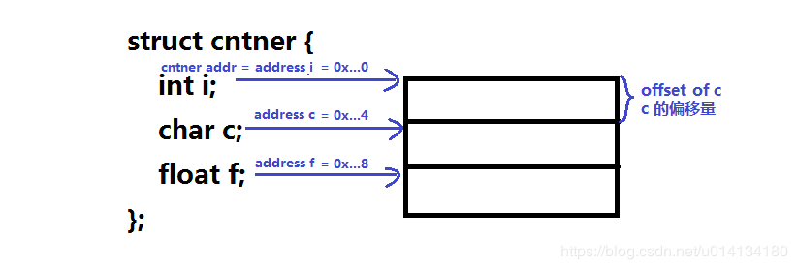
注：本文代码测试在64位的ubuntu系统中，关于上面字节对齐疑问请参见：https://blog.csdn.net/u014134180/article/details/78335328#6_488

我们看看下面几个container_of 宏的实现：

container_of 宏 版本一
这个宏定义出自 msm-4.9\drivers\gpu\drm\nouveau\include\nvif\list.h

/**
* Returns a pointer to the container of this list element.
*
* Example:
* struct foo* f;
* f = container_of(&foo->entry, struct foo, entry);
* assert(f == foo);
*
* @param ptr Pointer to the struct list_head.
* @param type Data type of the list element.
* @param member Member name of the struct list_head field in the list element.
* @return A pointer to the data struct containing the list head.
*/
#ifndef container_of
#define container_of(ptr, type, member) \
(type *)((char *)(ptr) - (char *) &((type *)0)->member)
#endif

下面我们编写一个测试代码

#include <stdio.h>
#define container_of(ptr, type, member) ( (type*) ((char*)(ptr) - ((char*)&((type*)0)->member)) )

struct cntner {
int i; char c; float f;
};

int main(void)
{
struct cntner init_struct ={.i=2019,'c',2019.0122};
char *pc = &init_struct.c;

struct cntner *pcntner = container_of(pc, struct cntner, c);
printf(" &init_struct = %p\n", &init_struct);
printf(" = pcntner = %p\n", pcntner);
printf(" (pc) = %p\n", (pc) );
printf("((char*)&((struct cntner*)0)->c) = %p\n", ((char*)&((struct cntner*)0)->c) );
//warning: format ‘%p’ expects argument of type ‘void *’, but argument 2 has type ‘long int’
//printf(" = %p\n", ((char*)(pc) - ((char*)&((struct cntner*)0)->c)) );
printf("(struct cntner*) ((char*)(pc) - ((char*)&((struct cntner*)0)->c)) = %p\n", \
(struct cntner*)((char*)(pc) - ((char*)&((struct cntner*)0)->c)) );
// output other people
printf("init_struct.i = %d\n", pcntner->i);
printf("init_struct.c = %c\n", pcntner->c);
printf("init_struct.f = %f\n", pcntner->f);

return 0;
}

运行结果如下，读者用其他变量可以测试一下container_of

wucb0122@wucb0122-ubuntu14:~/Codes/test$ gcc container_of.c
wucb0122@wucb0122-ubuntu14:~/Codes/test$ ./a.out
&init_struct = 0x7ffe1a9a7d80
= pcntner = 0x7ffe1a9a7d80
(pc) = 0x7ffe1a9a7d84
((char*)&((struct cntner*)0)->c) = 0x4
(struct cntner*) ((char*)(pc) - ((char*)&((struct cntner*)0)->c)) = 0x7ffe1a9a7d80
init_struct.i = 2019
init_struct.c = c
init_struct.f = 2019.012207
wucb0122@wucb0122-ubuntu14:~/Codes/test$

